Nurtai Maksat. Logistic Regression

For this lab I found an interesting dataset. These are tic-tac-toe. This database encodes the complete set of possible board configurations at the end of tic-tac-toe games, where "x" is assumed to have played first. The target concept is "win for x". Dataset look like this:

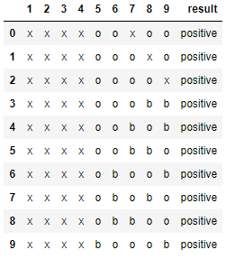

And this is not correct for the training model. To fix the library used LabelEncoder(). For training models used LogisticRegression. This is how I understand it is used to describe the data and explain the relationship between one dependent binary variable and one or several nominal, ordinal values. If you rely on this data, you can see that my model made quite a few mistakes in my opinion.

